**Definitions of open access-**

2002 [Budapest Open Access Initiative](http://en.wikipedia.org/wiki/Budapest_Open_Access_Initiative)

June, 2003 [Bethesda Statement on Open Access Publishing](http://en.wikipedia.org/wiki/Bethesda_Statement_on_Open_Access_Publishing)

October, 2003 [Berlin Declaration on Open Access to Knowledge in the Sciences and Humanities](http://en.wikipedia.org/wiki/Berlin_Declaration_on_Open_Access_to_Knowledge_in_the_Sciences_and_Humanities)

**OA Journal- does it meet criteria based on definition?**

**Why publish in OA?**

Maximising the true impact of your research goes beyond the traditional impact “factor”. It is realised in the global dissemination of research including to researchers who do not have access to journals published behind paywalls. [say more about OA models?]

**Where do CC licences fit into this?**

The Creative Commons copyright licenses and tools forge a balance inside the traditional “all rights reserved” setting that copyright law creates.

**What is the effect of my licence choice on re-use?**

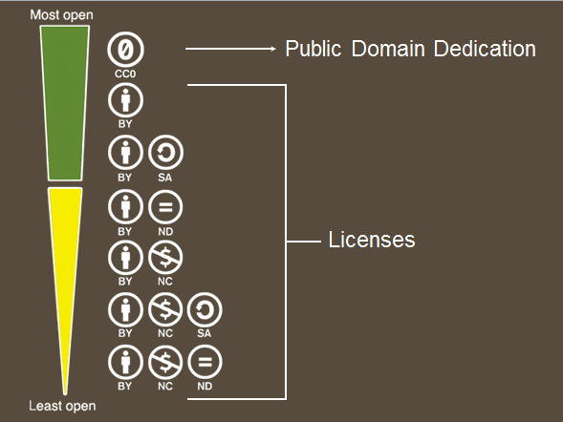

The four conditions

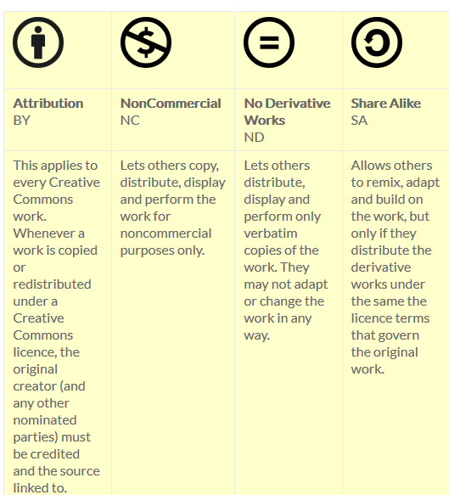

<http://creativecommons.org.au/learn/licences/>

Expressed in six licences

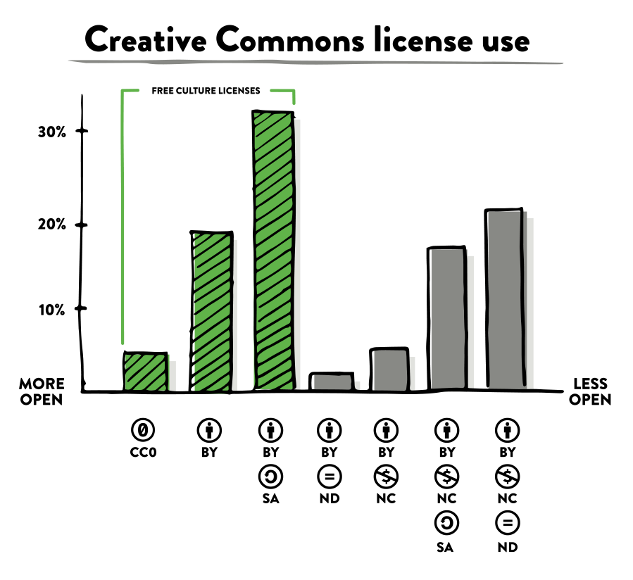

<http://stateof.creativecommons.org/>

|  |  |  |  |  |
| --- | --- | --- | --- | --- |
| File:Open Access logo PLoS white.svg | CC BY  by | [View License Deed](https://creativecommons.org/licenses/by/4.0)  [View Legal Code](https://creativecommons.org/licenses/by/4.0/legalcode) | **This applies to every Creative Commons work. Whenever a work is copied or redistributed under a Creative Commons licence, the original creator (and any other nominated parties) must be credited and the source linked to.**  (condition words)  This license lets others distribute, remix, tweak, and build upon your work, even commercially, as long as they credit you for the original creation. | by  This is the most accommodating of licenses offered. Recommended for maximum dissemination and use of licensed materials.   * Use with attribution * Share- no restrictions * Share- share alike * Share- no derivatives ie. no adaptation * Make Commercial use |
|  | CC BY-SA  bysa | [View License Deed](https://creativecommons.org/licenses/by-sa/4.0)  [View Legal Code](https://creativecommons.org/licenses/by-sa/4.0/legalcode) | **Allows others to remix, adapt and build on the work, but only if they distribute the derivative works under the same the licence terms that govern the original work.**  (condition words)  This license lets others remix, tweak, and build upon your work even for commercial purposes, as long as they credit you and license their new creations under the identical terms. This license is often compared to “copyleft” free and open source software licenses. All new works based on yours will carry the same license, so any derivatives will also allow commercial use. This is the license used by Wikipedia, and is recommended for materials that would benefit from incorporating content from Wikipedia and similarly licensed projects. | by-sa |
|  | CC BY –ND  bynd | [View License Deed](https://creativecommons.org/licenses/by-nd/4.0)  [View Legal Code](https://creativecommons.org/licenses/by-nd/4.0/legalcode) | **Lets others distribute, display and perform only verbatim copies of the work. They may not adapt or change the work in any way.**  (condition words)  This license allows for redistribution, commercial and non-commercial, as long as it is passed along unchanged and in whole, with credit to you. | by-nd   * translate |
|  | CC BY-NC  bync | [View License Deed](https://creativecommons.org/licenses/by-nc/4.0)  [View Legal Code](https://creativecommons.org/licenses/by-nc/4.0/legalcode) | **Lets others copy, distribute, display and perform the work for noncommercial purposes only.**  (Condition words)  This license lets others remix, tweak, and build upon your work non-commercially, and although their new works must also acknowledge you and be non-commercial, they don’t have to license their derivative works on the same terms. | by-nc   * $ |
|  | CC BY-NC-SA  bync  sa | [View License Deed](https://creativecommons.org/licenses/by-nc-sa/4.0)  [View Legal Code](https://creativecommons.org/licenses/by-nc-sa/4.0/legalcode) | This license lets others remix, tweak, and build upon your work non-commercially, as long as they credit you and license their new creations under the identical terms. | by-nc-sa |
|  | CC BY-NC-ND  byncnd | [View License Deed](https://creativecommons.org/licenses/by-nc-nd/4.0)  [View Legal Code](https://creativecommons.org/licenses/by-nc-nd/4.0/legalcode) | This license is the most restrictive of our six main licenses, only allowing others to download your works and share them with others as long as they credit you, but they can’t change them in any way or use them commercially. | by-nc-nd |
| http://upload.wikimedia.org/wikipedia/commons/thumb/0/0e/Closed_Access_logo_transparent.svg/491px-Closed_Access_logo_transparent.svg.png | © All Rights Reserved |  | This is the default copyright position. The user can NOT exercise any rights, generally, reproduce, distribute, display, and make adaptations without permission. | ©  Free to read. No re-use other than allowed by statutory exceptions or licences; or, permission from the copyright owner. |
| Logos from “HowOpenIsIt?™ Open Access spectrum”, © 2013 SPARC and PLOS, licensed under CC BY | | | | |